**Contents**

**Week 1**

1. **My learning**

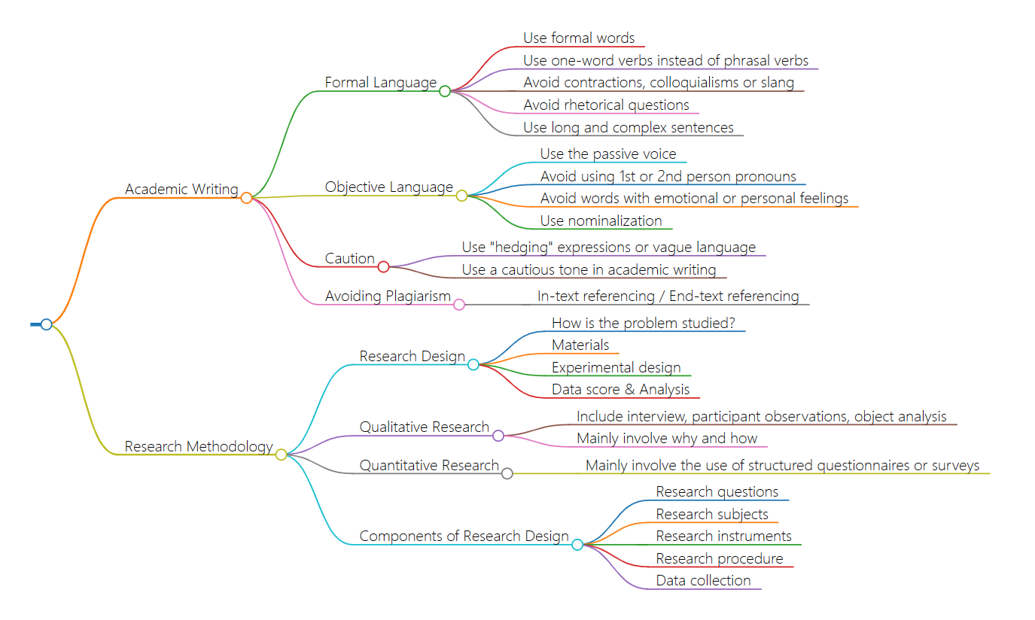

1. **Learning outcomes**

* Academic papers need to use formal language, avoiding slang, colloquialisms, and abbreviations.In future writing, I will follow the rules of academic writing, using formal language, including avoiding slang and colloquialisms, using a word verb, etc. This can make my copy writing more professional and more suitable for publication in professional settings.
* Use objective language, try to avoid first-person or second-person pronouns, use passive voice and nounization to maintain objectivity.In the future writing process, I will try to maintain objective language, use passive voice and nounization, and avoid using first- or second-person pronouns. This preserves the objectivity of the article and increases persuasiveness.
* In academic papers, expressions should be used carefully, using "wording" expressions, and trying to avoid using too many subjective expressions.In my future writing, I will use "wording" to strengthen my expression, using words such as "probably", "seeming", "maybe" and so on to express my opinion, leaving room for myself and expressing my respect.
* Academic papers should pay attention to literature citation and try to avoid plagiarism.In my future writing, I will pay attention to literature citation to avoid plagiarism and infringement. I will reasonably quote the research of other scholars to make my articles more convincing and in line with academic norms.

1. **My behavior and attitude**

* Good concentration and endurance, showing high concentration and endurance in the learning process, able to concentrate on completing tasks.
* Not active in the classroom.

**4．Improvement**

Outstanding students will actively participate in class discussions and activities, express their own opinions and questions, and should be more active in class activities and questions